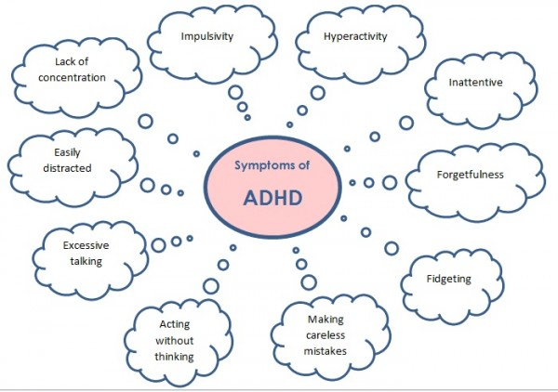**Symptoms of ADHD**

ADHD used to be known as **attention deficit disorder**, or **ADD**. In 1994, it was renamed ADHD and broken down into three subtypes, each with its own pattern of behaviors:

1. **an inattentive type**, with signs that include:

* inability to pay attention to details or a tendency to make careless errors in schoolwork or other activities
* difficulty with sustained attention in tasks or play activities
* apparent listening problems
* difficulty following instructions
* problems with organization
* avoidance or dislike of tasks that require mental effort
* tendency to lose things like toys, notebooks, or homework
* distractibility
* forgetfulness in daily activities

1. **a hyperactive-impulsive type**, with signs that include:

* fidgeting or squirming
* difficulty remaining seated
* excessive running or climbing
* difficulty playing quietly
* always seeming to be "on the go"
* excessive talking
* blurting out answers before hearing the full question
* difficulty waiting for a turn or in line
* problems with interrupting or intruding

1. **a combined type**, which involves a combination of the other two types and is the most common

Although it can be challenging to raise kids with ADHD, it's important to remember they aren't "bad," "acting out," or being difficult on purpose. And they have difficulty controlling their behavior without medication or behavioral therapy.

[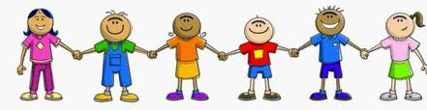](http://www.google.com/imgres?hl=en&sa=X&qscrl=1&rlz=1T4GGNI_enUS499US499&biw=1441&bih=676&tbm=isch&prmd=imvns&tbnid=jMZu5KTNNN1zMM:&imgrefurl=http://sfmcsped.wordpress.com/testing-creating-behavioral-goals-for-the-iep/&docid=XcAHFHl3i0ip6M&imgurl=http://sfmcsped.files.wordpress.com/2011/04/cropped-pta20kids20clipart_small.jpg&w=770&h=200&ei=76eKUMaHFIaOygGA34GAAQ&zoom=1&iact=hc&vpx=956&vpy=448&dur=3299&hovh=114&hovw=441&tx=337&ty=90&sig=109817504177312775117&page=1&tbnh=67&tbnw=253&start=0&ndsp=28&ved=1t:429,r:0,s:20,i:136)

This information was provided by the Charleston Promise Neighborhood; written by KidsHealth®, one of the largest resources online for medically reviewed health information written for parents, kids, and teens. For more articles like this, visit KidsHealth.org or TeensHealth.org. © 1995-2012. The Nemours Foundation/KidsHealth®. All rights reserved.