C:\Users\Pamela\AppData\Local\Microsoft\Windows\Temporary Internet Files\Low\Content.IE5\4HL45PUR\MC900272344[1].WMF **Ringworm**

Ringworm is NOT a worm at all but an infection caused by a fungus. It can affect the scalp, skin, fingers, toe nails, or foot. Many times, several patches of ringworm appear at the same time. Ringworm can affect anyone, but children are more likely to get it.

**What does Ringworm look like?**

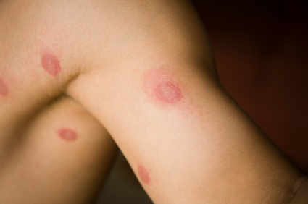Of the skin: Ringworm of the skin starts as a red, scaly patch or bump. Ringworm tends to be very itchy and uncomfortable. Over time, it may begin to look like a ring or a series of rings with raised, bumpy, scaly borders (the center is often clear). This ring pattern gave ringworm its name, but not every person who's infected develops the rings.

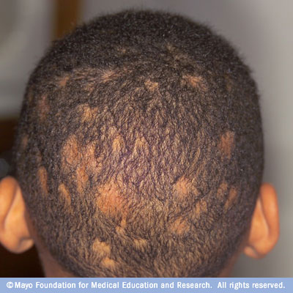Of the feet: When ringworm affects the feet it's known as athlete's foot, and the rash, which is usually between a person's toes, appears patchy. In fact, the rashes a person gets with athlete's foot may not look like rings at all — they may be red, scaly patches.

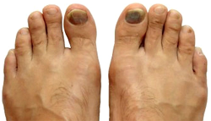Of the scalp: Ringworm of the scalp may start as a small sore that resembles a pimple before becoming patchy, flaky, or scaly. If ringworm affects your hair, you will have bald patches. It can also cause the place where the infection is to become swollen, tender, and red.

Of the nails: If ringworm affects the nails, they will become discolored, thick, and even crumble. Ringworm of the nails is not too common before children reach their teens, though.

C:\Users\Pamela\AppData\Local\Microsoft\Windows\Temporary Internet Files\Low\Content.IE5\R6HY0L5T\MC900070936[1].WMF**What causes Ringworm?**

C:\Users\Pamela\AppData\Local\Microsoft\Windows\Temporary Internet Files\Low\Content.IE5\VYUPM2DH\MC900215062[1].WMF Ringworm is common, especially among children, and, again, is caused by a fungus. Many bacteria and fungi live on the body. Some of these are useful, while others can cause infections. Ringworm occurs when a type of fungus called tinea grows and multiplies on your skin.

C:\Users\Pamela\AppData\Local\Microsoft\Windows\Temporary Internet Files\Low\Content.IE5\4HL45PUR\MC900330300[1].WMFC:\Users\Pamela\AppData\Local\Microsoft\Windows\Temporary Internet Files\Low\Content.IE5\TK3BDOZY\MC900438127[1].WMFRingworm can spread easily from one person to another. You can catch ringworm if you touch someone who has the infection, or if you come into contact with items contaminated by the fungus, such as combs, unwashed clothing, and shower or pool surfaces. You can also catch ringworm from pets that carry the fungus. Cats are common carriers.

The fungus that causes ringworm live in warm, moist areas. Ringworm is more likely when you are often wet (such as from sweating) and from minor injuries to your skin, scalp, or nails.

**What is the treatment for Ringworm?**

Most of the time, the doctor can diagnose ringworm by looking at your skin. So, if you discover a red, patchy, itchy area that you think may be ringworm, call your doctor.

**How Is Ringworm Treated?**

Fortunately, ringworm is fairly easy to diagnose and treat.

To care for ringworm:

* Keep the skin clean and dry.
* Apply over-the-counter antifungal or drying powders, lotions, or creams that contain miconazole, clotrimazole, or similar ingredients.
* Don't wear clothing that rubs against and irritates the area.
* Wash sheets and nightclothes every day when infected.

Your health care provider may prescribe pills to treat the fungus if you have:

* A severe case of ringworm
* Ringworm that keeps coming back or that lasts for a long time
* Ringworm in your hair

You may need medicines such as ketoconazole, which are stronger than over-the-counter products. You may also need antibiotics to treat skin infections from strep or staph that are caused by scratching the area.

Infected pets also should be treated.

**What is the Outlook (Prognosis) of someone who has Ringworm?**

Skin medicine usually treats ringworm within 4 weeks. If the ringworm infection is severe or it does not respond well to self-care, it will usually respond quickly to antifungal pills.

**When should I contact a Medical Professional?**

C:\Users\Pamela\AppData\Local\Microsoft\Windows\Temporary Internet Files\Low\Content.IE5\B7GS8FSB\MC900390944[1].WMFCall the doctor right away if you have any signs of a bacterial infection, which can result from scratching. These signs include swelling, warm skin, sudden worsening in redness of the patches, red streaking, pus, drainage, and fever.

Call the doctor if:

* The ringworm is on the scalp or beard
* The skin does not improve after 4 weeks of self-care
* The rash spreads and you have
  + diabetes or
  + a weakened immune system due to

a disease or

certain medications

C:\Users\Pamela\AppData\Local\Microsoft\Windows\Temporary Internet Files\Low\Content.IE5\UFSIJVY6\MC900100706[1].WMF**How do I prevent Ringworm?**

To prevent ringworm:

* Keep your family’s skin and feet clean and dry.
* Shampoo regularly, especially after haircuts.
* C:\Users\Pamela\AppData\Local\Microsoft\Windows\Temporary Internet Files\Low\Content.IE5\QY9VRC1W\MC900412552[1].WMFDo not share clothing, towels, hairbrushes, combs, headgear, or other personal care items. Such items should be thoroughly cleaned and dried after use.
* Wear sandals or shoes at gyms, lockers, and pools.
* C:\Users\Pamela\AppData\Local\Microsoft\Windows\Temporary Internet Files\Low\Content.IE5\8WCQC7YV\MC900391408[1].WMFAvoid touching pets with bald spots.

Sources:

[http://kidshealth.org/teen/infections/fungal/ringworm.html#](http://kidshealth.org/teen/infections/fungal/ringworm.html); http://www.mayoclinic.com/health/ringworm/DS00489/DSECTION=symptoms; <http://www.health.ny.gov/diseases/communicable/ringworm/fact_sheet.htm>

Charleston Promise Neighborhood is a non-profit organization that works to improve the lives of children and families in the 5.6 square mile area of the “neck” between Charleston and North Charleston. KidsWell is Charleston Promise Neighborhood’s health and wellness initiative that includes School-Based Health Clinics at Sanders-Clyde Creative Arts School, James Simons Elementary, Chicora School of Communications, and Mary Ford Elementary. [www.charlestonpromise.org](http://www.charlestonpromise.org)

The information in this document is not intended or implied to be a substitute for professional medical advice, diagnosis or treatment. Charleston Promise Neighborhood disclaims any warranty or liability for your use of this information.

**For additional information, contact your child’s doctor or school nurse.**