**Eczema (Atopic Dermatitis)**

[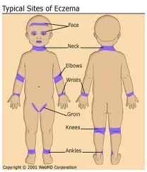](http://www.google.com/imgres?hl=en&sa=X&tbo=d&biw=1093&bih=490&tbm=isch&tbnid=T36uM7Ed9lanBM:&imgrefurl=http://www.webmd.com/skin-problems-and-treatments/eczema/understanding-eczema-basics&docid=YkRoGC4gSyJuXM&imgurl=http://img.webmd.com/dtmcms/live/webmd/consumer_assets/site_images/articles/health_and_medical_reference/skin_and_beauty/understandingdermatitisbasics_eczema.jpg&w=280&h=326&ei=GtYLUZCoEqTG2wW6hYHADA&zoom=1&ved=1t:3588,r:12,s:0,i:186&iact=rc&dur=1123&sig=117831886736847964027&page=2&tbnh=192&tbnw=170&start=9&ndsp=11&tx=105&ty=127)**What is Atopic Dermatitis (Eczema)?**

Eczema is a general term for rash-like skin conditions. The most common type of eczema is called atopic dermatitis, which is an allergic condition. Atopic dermatitis is a long-term skin disease.

“Atopic” refers to a tendency to develop allergy conditions. “Dermatitis” means swelling of the skin.

**What are the signs and symptoms?**

The most common symptoms of atopic dermatitis are:

* Dry and itchy skin
* Rashes on the face, inside the elbows, behind the knees, and on the hands and feet.

The rash may become very red, swollen, and sore. The more you scratch it, the worse it may get. A clear fluid may leak from the rash. Eventually the rash will crust over and start to scale. Often the skin gets worse (flares); then it improves or clears up (remissions).

**Who gets atopic dermatitis?**

You can’t “catch” the disease or give it to other people. However, you are more likely to have atopic dermatitis or eczema if a family member has it. The exact cause of eczema and atopic dermatitis is unknown although it is likely to run in the family and be caused by environmental factors. People with atopic dermatitis may go on to develop hay fever and asthma.

**What makes atopic dermatitis worse?**

Irritants and allergens can make atopic dermatitis worse.

Irritants are things that may cause the skin to be red and itchy or to burn. They include:

* Wool or manmade fibers (wear cotton or manmade fibers)
* Soaps and cleaners (use mild, unscented soaps like Dove, Basis, or Oil of Olay)
* Some perfumes and makeup
* Substances such as chlorine, mineral oil, or solvents
* Dust or sand
* Cigarette smoke.

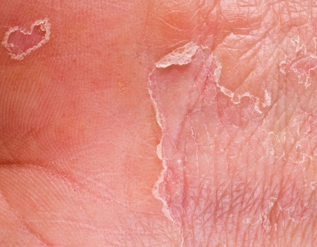Allergens are allergy-causing substances from foods, plants, animals, or the air. Common allergens are:

* Eggs, peanuts, milk, fish, soy products, and wheat
* Dust mites
* Mold
* Pollen
* Dog or cat dander

**What else makes atopic dermatitis worse?**

Stress, anger, and frustration can make atopic dermatitis worse, but they haven’t been shown to cause it.

Skin infections, temperature, and climate can also lead to skin flares.

**What can I do to manage atopic dermatitis?**

[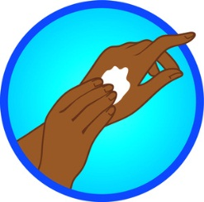](http://rosiepiter.com/clipart_illustrations/hands_applying_lotion_0071-1102-1114-1415_SMU.jpg)Be sure to lubricate the skin after a bath; use products that are more greasy than creamy. Take shorter (15-20 minutes) warm baths/showers, not long hot ones. Bathe with mild, unscented soap. Pat the skin dry instead of rubbing dry. Avoid getting too hot and sweaty. And continue skin care even after the skin has healed.

**What do I do if my child has atopic dermatitis?**

See your doctor. He/she will help to develop a good skin care routine, talk about avoiding things that cause flares, and treat symptoms when they occur.

The doctor may prescribe skin creams or ointments that control swelling and lower allergic reactions, antibiotics to treat any infection caused by bacteria, and/or antihistamines to stop itching, among other treatments. You and your family members should watch for changes in the skin to find out what treatments help the most.

Adapted from: <http://www.niams.nih.gov/Health_Info/Atopic_Dermatitis/atopic_dermatitis_ff.asp>; http://familydoctor.org/familydoctor/en/diseases-conditions/eczema-and-atopic-dermatitis.printerview.all.html