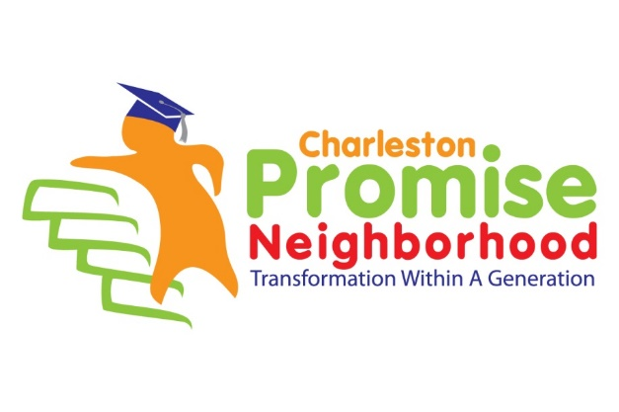

**CPN volunteer INFORMATION**

**NAME:** ______________________________________________________________________________

**ORGANIZATION/POSITION: ______________________________________________________**

**MAILING ADDRESS**: ___________________________________________________________________ **PHONE NUMBER: ______________________________________________________________**

**EMAIL ADDRESS: ______________________________________________________________**

**PREFERRED METHOD OF CONTACT (CIRCLE ONE):**  Email Telephone

**AVAILABILITY: Circle all that apply:**

* **Day**
* **Evening**
* **Weekends**
* **Flexible**

**AREAS OF INTEREST/SKILLS TO SHARE: _________________________________________________________________________**

**_________________________________________________________________________**

**TYPE OF VOLUNTEER: (One-time event, Episodic/Ongoing, Custom project, Strategic, Micro volunteer)**

**Refer to back page for opportunities.**

**HOW DID YOU HEAR ABOUT THE CHARLESTON PROMISE NEIGHBORHOOD?**

*CPN STAFF ONLY: (NOTE: Information to be entered into ETAP and uploaded to Constant Contact)*

*Contact entered into ETAP: _________ Contact in Constant Contact: ______*

|  |  |  |
| --- | --- | --- |
| **Charleston Promise Neighborhood Volunteer Opportunities** | | |
| **VOLUNTEER OPPORTUNTY** | **DESCRIPTION** | **TIMEFRAME/ FREQUENCY** |
| **Episodic: One time commitment/Single Events** | | |
| Trident United Way Day of Caring - with Schools/Community | TBD;Past Projects: Career day, middle school to high school transition, adopt a teacher, reading groups, teaching healthy habits, intro to software engineering, gardening/beautification;painting | November 15, 2019 |
| Aquarium Night | Families invited to a special night at the Aquarium. | Annual/TBD |
| Gentrification Forums | Quarterly forums to explore different aspects of gentrification and the opportunities/resources available for residents | Sept. 19, 2019 (Housing) |
| Social Studies Bowl | Teams of students in Grades 25 compete against each other | TBD |
| **School-specific** | | |
| Duty Free Lunch | Sit with a group of students during lunch | School Year/Monthly |
| Adopt a Teacher/Class | Spend a few hours a week/day with teacher providing assistance as needed | School Year/Monthly |
| Small Group Reading | Meet with 4 – 6 year old students and read in small groups | School Year/Monthly |
| Health Screenings | Help with Vision, Hearing, and Dental Screenings, BMI supports | First quarter |
| Program Delivery | Individual/group offers instruction to a student (e.g., Financial Literacy, Self-esteem workshop) | School Year |
| Testing Support/Hall monitors | Provide support during key testing weeks and help teachers escort students to restroom | School year (Fall and Spring) |
| Family Engagement Nights | Help with Family Science Nights, Family Health Nights, Family Literacy Nights, Family Math Night, | 6-8 times/year |
| Uniform Drive | Help support year round needs for uniforms | School Year |
| Sock and Undergarment Drive | Help support the MUSC KidsWell School-based Health program – providing new socks and undergarments to students | School Year |
| **Expanded Learning Time/After School Programs** | | |
| Counselor/provider support | Provide assistance in one of the afterschool programs at Sanders-Clyde or Mary Ford | School Year (2:30 – 5:30 pm) |
| **Organization and/or Individual designed project** | | |
| Volunteer project designed with CPN | Designed by individual or groups in collaboration with Charleston Promise Neighborhood – Community or school-based | Year round |